Project Design Phase-II

Project Details | Field | Information | | :--- | :--- | | Date | 08/03/2026 | | Team ID | SWTID-2026-8952 | | Project Name | Product Inventory Management System (Backend) | | Maximum Marks | 4 Marks |

1. Data Flow Diagrams
A Data Flow Diagram (DFD) serves as a traditional visual model illustrating the movement of information throughout a system. When designed clearly and neatly, a DFD effectively captures the appropriate level of system requirements in a graphical format. It maps out the pathways data takes to enter and exit the system, identifies the processes that modify the information, and pinpoints where the data is stored.
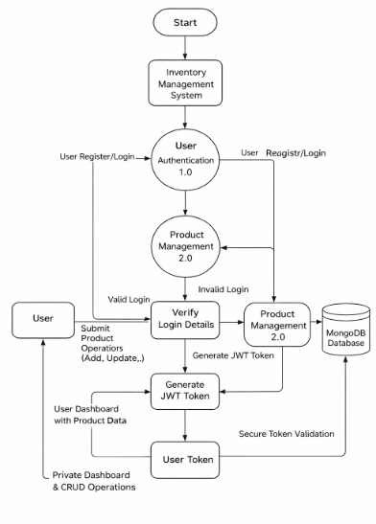
2. User Stories
Please utilize the template provided below to catalog all the user stories associated with the product.
User Type | Story No. | User Story / Task | Acceptance Criteria | Priority | Release
Customer (Web User) | USN-1 | "As a user, I can register and log in securely using JWT authentication" | User can create account and receive token after login | High | Sprint-1
Customer (Web User) | USN-2 | "As a user, I can add new products to my inventory" | Product is saved and visible only to logged-in user | High | Sprint-1
Customer (Web User) | USN-3 | "As a user, I can view all my products in a dashboard" | Products load successfully with valid token | High | Sprint-1
Customer (Web User) | USN-4 | "As a user, I can update product details like price and quantity" | Changes are saved and reflected instantly | Medium | Sprint-2
Customer (Web User) | USN-5 | "As a user, I can delete products from my inventory" | Product disappears from dashboard after deletion | Medium | Sprint-2
Customer (Web User) | USN-6 | "As a user, I can search products by name" | Filtered results appear based on keyword | Low | Sprint-2

